CURRICULOG: HOW TO START A NEW PROPOSAL in CURRICULOG - Preliminary Guide

Curriculog Link: https://samford.curriculog.com
- Click on Login (upper right corner).
- Use your usual Samford login (username and password). (This uses the CAS authentication process.)
- Any Samford faculty/staff member is allowed to access the Curriculog system.

Initial View

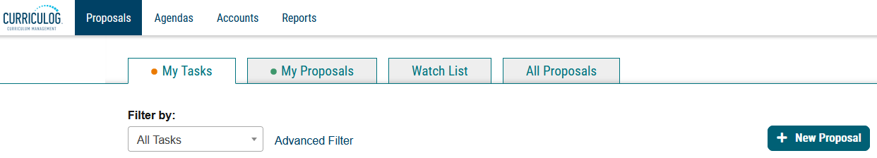

- Click on New Proposal.

You’ll see 14 blank proposals: Seven for Undergraduate items, Seven for Graduate items. Each of the seven is split out as follows: three for Courses (Creation, Revision, Deletion) and four for Programs (Creation-Traditional & Special-With Import, Revision, Deletion).

List of Blank Proposals (partial screenshot)
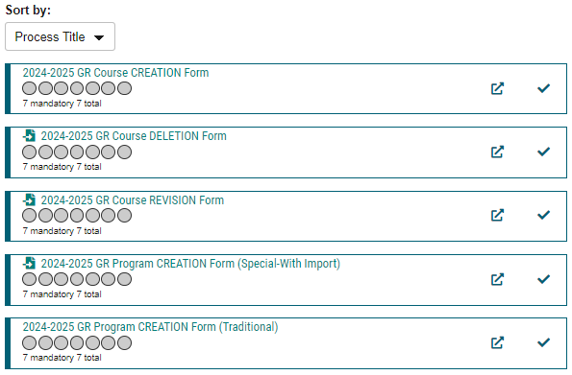

- Proposals are listed in alpha-numeric order, so the GR (Graduate) templates are listed first, followed by the UG (Undergraduate) ones.
- But proposals can also be filtered as follows: All Processes (default), Courses, Programs.
(Currently, there are no proposal templates under Others)

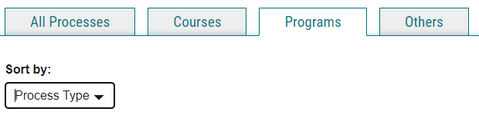
- Click on Courses or Programs and Sort by Process Title or Process Type. (Both sorting processes get you the same results—all the Courses or Program Proposals—but the Title vs Type just places them in a different order)

FYI about Proposal Templates:
- The grey circles change as a proposal goes through the approval process. From the home page, you can look at the listing under All Proposals to see how active proposals look as they move through a workflow. The grey circles will turn green with a thumb’s up icon or red w/a thumb’s down icon as they are approved or rejected.
- You can also click on the lowercase “i” icon in the upper right corner () to get a quick Curriculog Help page that explains the different icons:
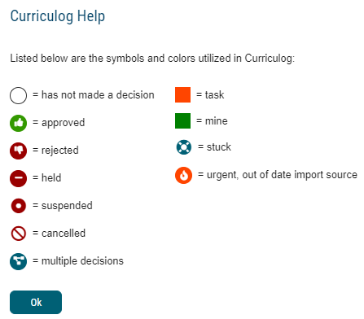
- You can also consult the glossary in the EndUserManual or CurriculogManual to learn what these and other icons mean. Both of these manuals are posted on the Curriculog Approvers & Users Teams page, under Files.
- The dark teal document icon w/an arrow indicates an import is tied to that proposal: . That will be seen in proposals that are revisions or deletions, as they will pull data from the current catalog (as of this writing, all templates are pulling data from a working version of the 24-25 catalog). Proposals for NEW items, obviously, do not pull data from the current catalog, hence the absence of that icon, except in one case (for the Special-With Import Program Creation form).
When you’re ready to start
- Choose a blank proposal/process. Example: GR Course Creation.
- Click the arrow on the far right to start a proposal. (The other icon will open a page preview of the template, but nothing can be entered. You might find this preview page handy to consult, however.)

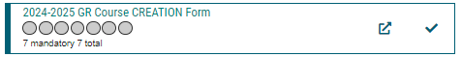

- It will open to look like this:

Initial View of a Course Creation Proposal (Graduate)
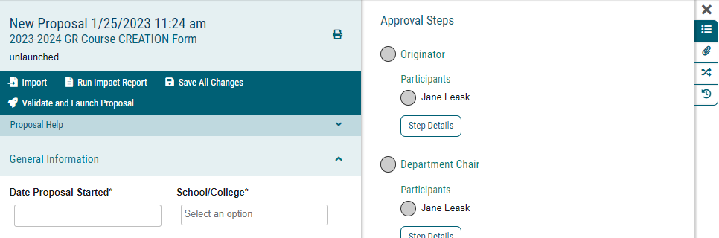

- You can click the X next to the Approval Steps to remove that from view and see the proposal in full page format. To bring back the Approval Steps section, just click on that icon (top right).

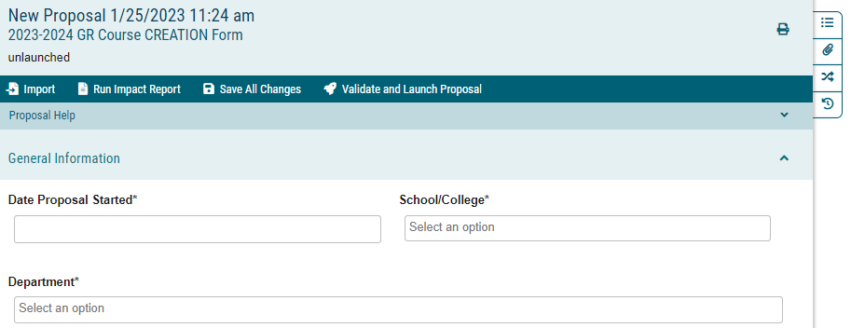

- Proceed to complete the form.
- Items with an asterisk are required before the form can be validated and launched.
- However, you can save a proposal (without submitting) and return to it later to complete the details. You can even do this without entering anything.
- At this stage (before you validate and launch a proposal), proposals you are drafting can be easily deleted by you (click on the trash can icon):

- While completing the form, especially for New Courses or New Programs, some fields won’t pre-populate, but clicking on them will generate a drop-down list of choices. In most of those cases, you will need to use your mouse to navigate the options. Typing your response will not always work with a drop-down list.

NOTE: New for the 24-25 forms, more fields are now pre-populated data that was extracted from Banner:
Course Level, Course Type, Degree Attribute (if available), Course Attribute (if any),
Default Grade Mode, Schedule Type, Repeat Status & Repeat Settings (if applicable)
That means you only need to focus on those fields if there is a revision—you don’t need to try to remember the current settings. However, we weren’t able to do this for prereqs and registration restrictions. That data is more complicated to extract from Banner, so it will not pre-populate.

- Most drop-down boxes allow for only one choice while others allow for multiple responses.
- If you’re adding a course syllabus, program of study, or any other document, Click the Files icon on the far right.
- WARNING: If you encounter issues where you’re not seeing what you think are the correct options in the drop-down list, etc., it could be that you chose the Grad form when you needed the Undergrad form, or vice versa. This happened to me often in testing. Otherwise, let me know about any issues.
- Feel free to Save All Changes as many times as needed while completing a proposal. It will ensure that your changes have been saved should the form lock up on you or you get interrupted and have to return later.
- When you are ready to submit, first click Save All Changes, then click Validate and Launch Proposal. If it takes too long, you might need to leave the form (click Proposals to back out) and then go back in.
- If a required field is not completed, you’ll see this prompt:
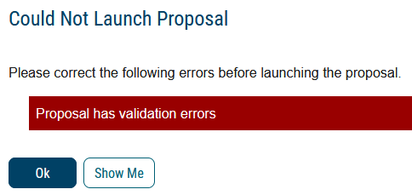

- Click Show Me and you’ll see the fields you’ve missed:
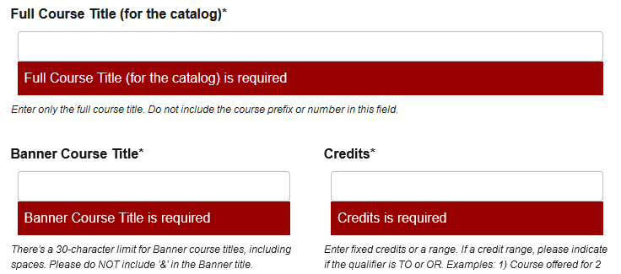
- If you’re not sure if a proposal has been launched, you will see the Status: Unlaunched line on the entry:

- If that’s the case, just go back into the form to complete, save, and validate/launch.

Once a proposal has been launched, it then goes through the workflow. The first step in the workflow is for the ORIGINATOR to approve it. After the proposal originator approves at step 1, it will follow the workflow and proceed to the next person in line. All approvers’ names have been plugged in beforehand, so there shouldn’t be anything else a user needs to do with regards to approvers.

Workflow Status (partial screenshot)
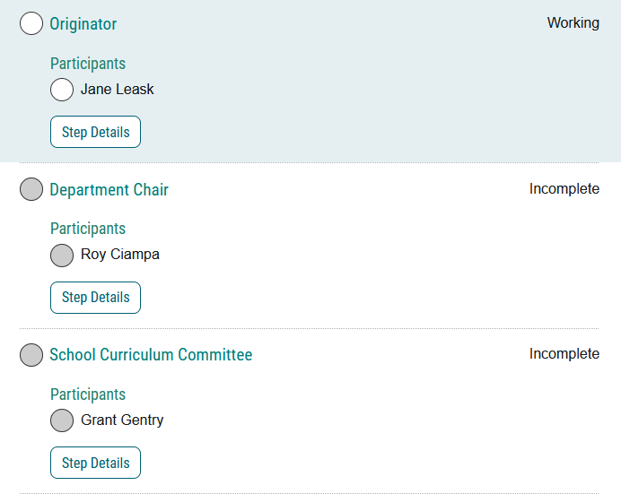

While this preliminary “how-to” document isn’t meant to be comprehensive for all Samford proposals, most of the forms are fairly intuitive and not very hard to complete. There is also a built-in “Walk Me Through” link that appears at the bottom right of the page to assist you as well. I will provide more how-to documents to cover specific issues as time permits. In the meantime, feel free to send me a question by email, phone, within Curriculog (explained below), or on the Teams page.

Another way to contact me with a question is to use the “Contact System Administrator” link at the bottom of every screen (see below).

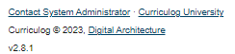

Updated 9/11/23
Jane Leask

